Statement of compliance

The application supports 3 kinds of users. A person may register to the forum by creating a user ID and a password or login if already registered. A unregistered user may only view threads, registered user may create a thread or delete his own thread also can reply to a thread and edit or delete his reply. Admin can edit, create or delete any thread or reply. All threads and replies display everything asked in the assignment except for date and time it was created.

I2

The system requirements are a Pc with minimal hardware and any browser.

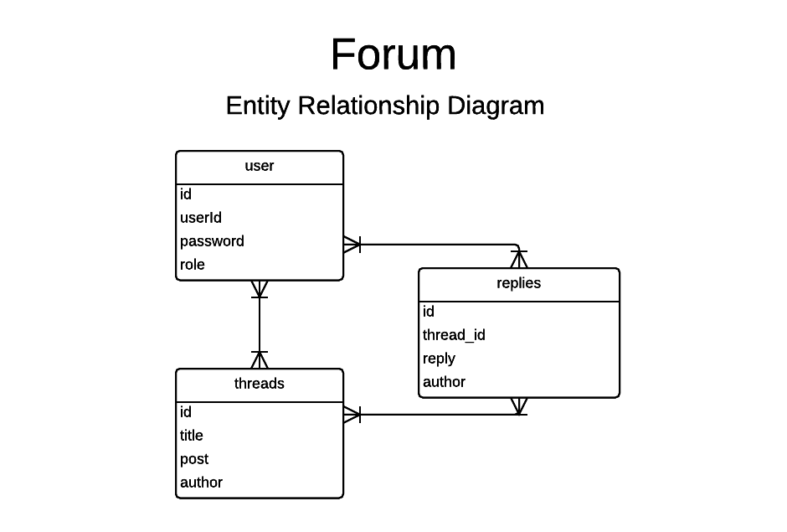

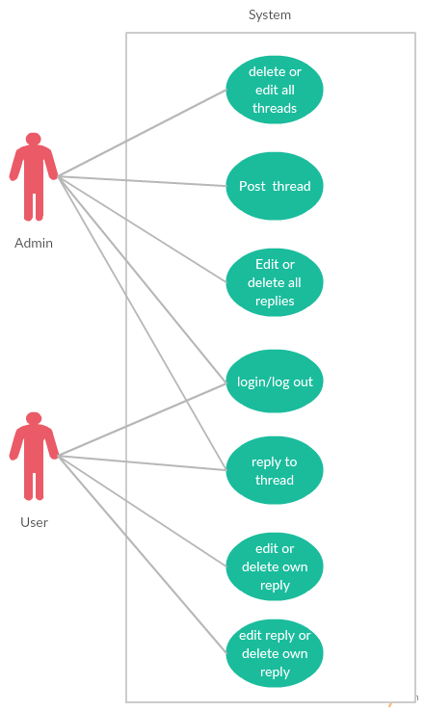

Index.php = to view all threads, go to login, logout or register page

Login.php = to login into account

Register.php = to register to the forum

Logout.php = to logout of your account

Postthread.php = to create a new thread

Thread.php?id=X = to view a certain thread, X being thread_id

editThread.php = to edit a thread

reply.php = to post a reply to a thread

editReply.php = to edit your reply

deleteReply.php = to delete your reply

deleteThread.php = to delete a thread

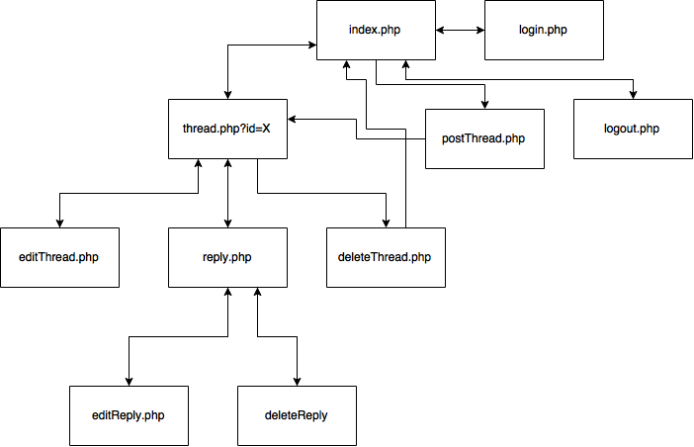

All measures have been implemented except for the time and date on threads and replies.

I3

|  |  |  |
| --- | --- | --- |
| **Purpose** | **Expected** | **Actual** |
| To create a user on register.php | A new user will be created into the database | A user was created into database but used id must be numbers or it will show you “Invalid password or user id” |
| To see if a thread can be created and visible to all individuals | A new thread should be created and should be seen by any person | Thread was created and can be seen by everyone |
| To see if admin can delete any thread and if a user can delete his own thread | Thread should be deleted for both user and admin | The threads were deleted |
| To see if user can reply and edit or delete his own reply | Reply should be created, edited or deleted | Reply was created then edited and deleted. |
| To see if admin can create a reply and edit or delete his any reply | Reply should be created and any other reply edited or deleted | Admin created a reply and can edit or delete any other reply in the forum. |
| To check if user and admin can login or logout | User or admin should be logged out or logged in | The user and admin was successfully logged in and logged out |
| To see if a unregistered user can view threads | The unregistered user should only be able to view threads | The unregistered user can view thread and nothing else except for registering or logging in. |

By – Eimantas Vitkauskis 1206549